PA2: Fuzzing Testing
CAP6135

Running Source Code:

Before running the fuzzer, ensure the working directory contains the following folders and files:

- cross.jpg
- crashes (this is where the mutated files are stored by the fuzzer)
- fuzzer.py
- jpeg2bmp

Run: python3 fuzzer.py

Design:

The design of my fuzzer uses the provided cross.jpg file as a seed input and repeatedly mutates it in order to discover bugs in the jpeg2bmp program. The fuzzer continuously generates mutated inputs and executes the target program for approximately 10 minutes.
During each iteration, the fuzzer randomly determines how many edits (mutations) will be applied to the input file. The distribution of edits is weighted so that most mutations are small changes, which helps maintain some valid JPEG structure and allows the program to process the file more deeply before failing. The mutation distribution is as follows:
- 70% probability: 1–3 edits (light mutations)
- 25% probability: 4–12 edits (moderate mutations)
- 5% probability: 20–60 edits (heavy corruption)
To further preserve some valid file structure, mutations are only applied after the first 100 bytes of the file. This prevents corruption of the JPEG header, which would otherwise cause the program to immediately reject the input before reaching deeper processing logic where many bugs occur.
The fuzzer implements six mutation strategies:
- Chunk overwrite (15%) – overwrites a sequence of bytes with random values
- Chunk duplication (10%) – copies a section of the file and inserts it elsewhere
- Byte overwrite (25%) – replaces a single byte with a random value
- Bit flip (25%) – flips a randomly selected bit within a byte
- Byte deletion (15%) – removes a byte from the file
- Byte insertion (10%) – inserts a random byte at a random position
For each mutation, a random value between 0 and 1 is generated to determine which mutation strategy will be applied.
After the file is mutated, the fuzzer executes the target program with the mutated file as input.
If a bug message of the form “CAP6135 Bug#n” is detected, the fuzzer records the bug number, increments a counter for that bug, and saves the corresponding mutated input file as test-n.jpg. These files serve as proof that the discovered inputs successfully trigger the associated bugs.
Throughout execution, the fuzzer tracks how many times each bug is triggered

Experimental Results:

The fuzzer was executed for approximately 10 minutes, generating thousands of mutated inputs and repeatedly executing the target program. During this time, the program detected multiple crashes corresponding to the inserted bugs. The following table summarizes how many times each bug was triggered during the fuzzing experiment.

 | Bug#1 | Bug#2 | Bug#3 | Bug#4 | Bug#5 | Bug#6 | Bug#7 | Bug#8 | Bug#9 | Bug#10
# of crashes triggered | 2195 | 499 | 512 | 160 | 1479 | 0 | 643 | 4719 | 14988 | 96816

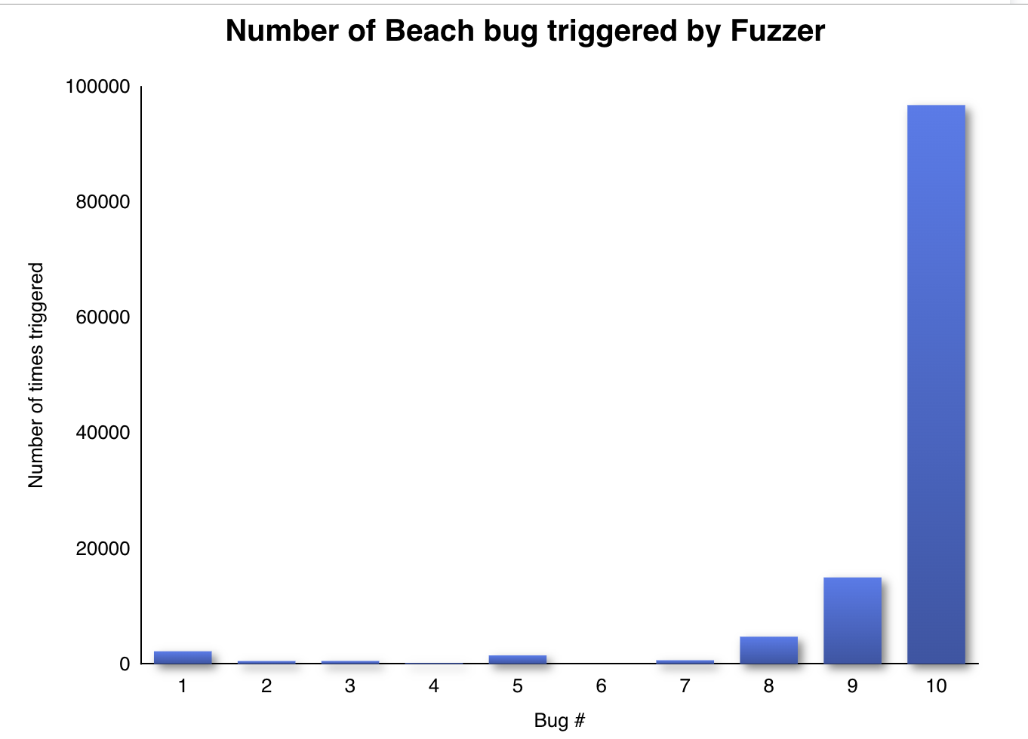

Proof of Finding Bugs:

